REGISTER YOUR CHILDREN or GRANDCHILDREN and their FRIENDS:
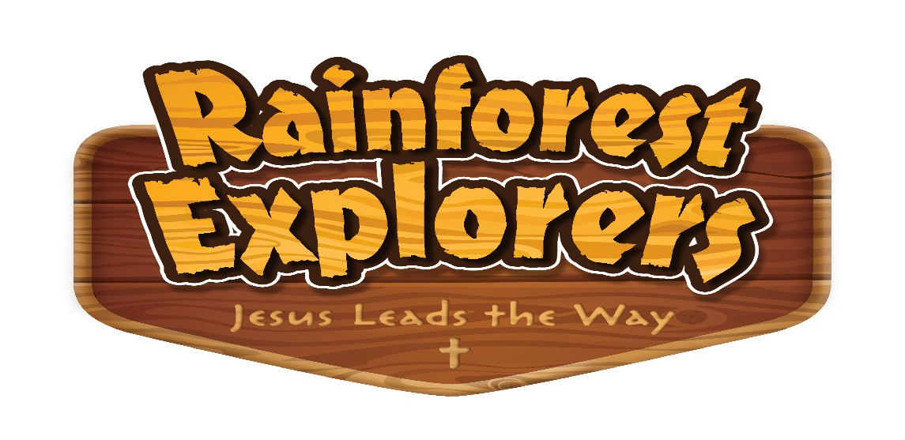

At Rainforest Explorer VBS, your children learn will how Jesus is our ultimate guide in the rainforest and throughout our lives.

Register now for Rainforest Explorer Vacation Bible School!
Registration is open for ages PreK-7th grade who will attend VBS from June 6-10, from 5:30-8:15pm. Come join us as we sing fun songs, do crazy crafts, play awesome games, and more. Can’t wait to see you there!
Please register by May 24th. Visitors are welcome so have your child invite their friends. Please have them register also.
You can register: online at www.myvbs.org/Trinity_Spencer, pick up a registration form in the narthex, fill it out and leave it in the office, e-mail Bonnie at trinity.spencer.wi@gmail.com, or call 715-659-4006.

A light supper will be served to the children as they arrive beginning at 5:00pm on Sunday through Thursday.
If you can volunteer as a helper, please call the church and leave a message at 659-4006.

REGISTER YOUR CHILDREN or GRANDCHILDREN and their FRIENDS:

Life is full of thrills and spills; we may not know what’s around the bend, but God does! At Splash Canyon, kids discover that, on life’s wild ride, Jesus is by our side. God saves us through Jesus and gives us life and hope every day and forever.

Register now for Splash Canyon Vacation Bible School!
Registration is open for ages PreK-7th grade who will attend VBS from June 10-14, from 5:30-8:00pm. Come join us as we sing fun songs, do crazy crafts, play awesome games, and more. Can’t wait to see you there!
Please register by May 25th. Visitors are welcome so have your child invite their friends. Please have them register also.
You can register: online at www.myvbs.org/Trinity_Spencer, pick up a registration form in the narthex, fill it out and leave it in the office, e-mail Bonnie at trinity.spencer.wi@gmail.com, or call 715-659-4006.

A light supper will be served to the children as they arrive beginning at 5:00pm on Sunday through Thursday. After the Thursday evening worship service there will be a presentation of the VBS closing followed by refreshments.
If you can volunteer as a helper, please call the church and leave a message at 659-4006.

